Commands used to provide the requested operations:

- For getting the indexes of the adapters and displays present in the system for all the GPUs:
Eyefinity.exe i
the output would be shown in the following format:

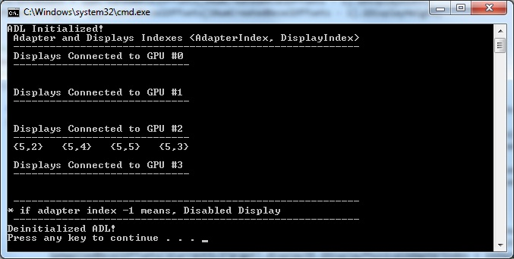
In the above screenshot shown, for GPU 0,1,3 – no displays are connected
For GPU 2 – Adapter index is 5 and display indexes are 2,4,5,3

- For creating Eyefinity:
Eyefinity.exe e13,2,3 m0,1,2,3,4,5
Here, 13 is the adapter index on which the Eyefinity should be created and the layout type is 2X3 (2 is column and 3 is row)
M is for display indexes – 0,1,2,3,4,5

- For disabling Eyefinity:
Eyefinity.exe d13
Here, 13 is the adapter index on which the Eyefinity should be disabled

- For re arranging the displays in Eyefinity:
Eyefinity.exe r13 m0,1,2,3,4,5
Here, 13 is the adapter index on which the Eyefinity is already created.
M is for display indexes – 0,1,2,3,4,5

- For setting the bezel offsets:
Eyefinity.exe b13 h100 v300
Here, 13 is the adapter index on which the Eyefinity is already created.
H is for horizontal offsets in pixels and v is the vertical offsets in pixels

- For setting a resolution:
Eyefinity.exe s13 x1920 y1200
Here, 13 is the adapter index on which the resolution should be changed
X is the horizontal resolution and y is the vertical resolution.

